Lessen Plan Title: Health & Safety - Part 3: Survival at sea and the safety checklist (part 3 of 4)

Trainer Name:
Training Time: 45 minutes

Prerequisites:
- Read Health & Safety chapter
- Modules: Navigation, Vessel Information, Health & Safety 1 & 2, MORE?

Audience: West African fisheries observers

Equipment:
- AV: LCD projector, computer, laser pointer
- Software: MS Powerpoint, MS Word, FinalMedia Player (for .vob files), RealPlayer (for .flv file),
- Files: health_safety_3.ppt, LP_ health_safety_3.doc
- Gear: n/a
- Activity: Safety Checklist

Before class, instructor should ….
- Get clarification from specific program regarding which types of gear are going to be required for an observer to board (ie if no life raft, does the observer board or not?)

Detailed text associated with ppt presentation. Note: any text in italics is additional information for the trainer and is not intended to be part of the lesson plan. Answers to the questions asked are in orange text.

Slide 1
The next health & safety module will focus on survival at sea and the safety checklist.
Briefly introduce the speaker if this is the first time he/she has spoken during the training.

Slide 2 Objectives:
By the end of this session, you will be able to…
- Recite 7 Steps to Survival from memory
- Build a personal survival kit using four basic components
- Demonstrate ability to complete the Safety Checklist

Slide 3 7 Steps to Survival
The United States Coast Guard assembled the Seven Steps to Survival from the personal experiences of those who survived emergency situations. Every time your situation changes (e.g., boarding a raft, reaching land, etc.), the seven steps begin again. We’ll address each in more detail but the steps include recognition, inventory, shelter, signals, water, food and play.

Slide 4 7 Steps - Recognition
You must quickly recognize you’re in trouble and that your life is in danger. Hesitation or denial may cost your life. Only abandon the ship when it is more dangerous on the boat than in the water.

Slide 5 7 Steps - Inventory
Take a little time to think about what you have that will help you survive and what are the hindrances. Inventory people including skills, injuries and mental state as well as equipment and the environment. Taking an inventory will help you to make good decisions that will help you survive.

Slide 6 7 Steps - Shelter
Effective shelters provide protection from the elements. Clothes are your primary shelter. Shelter can also be a raft, or an overturned vessel—anything that protects you against the loss (or gain) of body heat. Water can take heat away from your body much quicker than air, so shelter also helps you keep as dry as possible. High heat loss areas, including the head and neck, need to be protected most. The added buoyancy of a PFD helps to keep your head and neck out of water, therefore conserving heat.

Slide 7 7 Steps- Signals
Anything that attracts attention and conveys a message is a signal. Radios, EPIRBs, and flares are signals carried by most vessels. PFDs sometimes have lights attached. If abandoning ship, anything buoyant that can be tossed overboard may help an aircraft or another vessel spot your position. Anything that makes you bigger, brighter, or different from your surroundings is a signal, so an attempt to gather items which float from a sinking ship.

Slide 8 7 Steps
In a shore survival situation, three of anything such as fires, buoys is an internationally recognized distress signal. Additional features may include hard angles and contrast to the background. Ground signals should be three times as high as wide.

Slide 9 7 Steps - Water
Water needs increase with any activity. Life rafts have limited rations of water, so it is advised to gather as much as possible before abandoning ship, if time permits. Have a strategy for gathering extra water in an emergency. In a survival situation, there are only three safe sources of water: boiled, packaged or filtered. There are several very serious bacteria and other parasites one can acquire from drinking contaminated water (e.g. cholera, schistosomiasis). Never drink seawater or urine.

Slide 10 - 7 Steps - Food
A person can go without food much longer than without water. However, never eat food without water—your body requires water to digest food. Life rafts are supplied with limited food rations. In a shore survival situation, many types of edibles can be found near shore.

Slide 11 - 7 Steps - Play
Studies have shown that mental attitude makes a huge difference in the outcome of a survival situation. Play is anything that keeps you occupied and prevents your mind from dwelling on the difficulties you are facing. Play could be telling jokes or stories, completing a task, improving your shelter—anything that keeps your mind active and focused.

Slide 12 - Survival kits
Survival gear is not survival gear unless it’s with you. Most people arrive in a survival situation with only the clothing they’re wearing and what’s in their pockets. Its highly recommended to put together a small personal survival kit. The vessel (hopefully) will also have an abandon ship kit with some extra items. Regardless of the type, the essential elements of a survival kit include 1) some sort of shelter aid – something that may help you build a structure like string or a small tarp or keep you warm like a hat; 2) signals (e.g., whistle or mirror); 3) personal health needs (e.g., medications) and 4) fire starter.

Slide 13 - Personal survival kits
When creating your personal survival kit, think about what you’re willing to carry on your person at all times. Ideally, the kit should have items that may be used for multiple purposes. The exact content depends on your location and activity.

Slide 14 - Personal survival kits
I’ll use mine which is designed for cold water but at least you’ll get the idea. It fits into a small plastic bag and fits in the pocket of my PFD.

Slide 15 - Personal survival kits
I’ve broken down the contents by the elements:
- Numbers 1-5 are Shelter aids: 1. Poncho (could also be a signal), 2. line (shoelaces & dental floss), 3.zip tie, 4.hat, 5.toe warmer
- Numbers 6-8 are Signals: 6.whistle/compass, 7.bandanas, 8.Aluminum foil,
- Numbers 9-11 are Personal health: 9.hand towels (replaced w/ first aid cream), 10.vitamin C (might make bad water taste better), 11.pirate (fun) &regular bandaids, 12.prescription drugs (little tiny vial under bandaid tin)
- And finally there’s a lighter (#13) for lighting a fire (could also have waterproof matches)

Slide 16 Abandon ship kit
Some vessels prepare a larger abandon ship kit which might contain more water, a handheld VHF radio, stove, etc. Ideally, this should be a water tight container; have a handle & be accessible.

Slide 17 Survival Triad
The ability to survive an emergency situation at sea is dependent on three things: equipment, training and attitude. You have the ability and responsibility to make sure you understand all of your equipment and to ask vessel personnel to show you various components of some of the other survival equipment.

Slide 18 Safety Checklist
The Safety Checklist is a 1-page form in the Observer Logbook and is designed to aid in familiarizing observers with safety procedures and equipment before departing the dock for the first time on each vessel. The top section of the Safety Checklist must be completed upon boarding
The safety checklist is mostly a list of yes or no questions but also asks for life raft capacity & the presence of other types of safety equipment. It’s fairly self-explanatory but let’s go over each section in a little more detail.

Slide 19 Safety Checklist
The Pre-departure Yes/No questions include:
- Were you informed of the general safety procedures for the vessel?
- Were alarm signals demonstrated for each type of emergency? If the vessel does not actually sound separate signals for fire/flooding, abandon ship and person overboard, circle NO. Do you remember what these are? [1 long blast not less than 10 seconds], [7 short + 1 long] & [3 long repeated 4 times], respectively
- Did you examine escape routes from accommodations and work areas?
- Where is your muster station in case of an emergency?
- Who is the person in charge of medical treatment?
- Were you shown the location of radios /navigation equipment and provided with instructions for use?

Slide 20 Safety Checklist
If your vessel has a life raft with a label, record the model, number of persons it can hold, last inspection date. Even if it doesn’t have a label, record the capacity & provide a description.

Slide 21 Safety Checklist
Also record, the location of all survival craft. Circle yes if it was in a float free location, if it had a hydrostatic release present and if the hydrostatic release was attached properly. Some hydrostatic releases also have inspection dates. If this is the case, you can record this in the comment section.

Circle yes or no for whether or not there was adequate life raft capacity on board including the observer. And note whether the raft was packed with a SOLAS kit.

Slide 22 Safety Checklist
In our example, the solas kit is a B

Slide 23 Safety Checklist
For EPIRBs, also record the model, battery expiration date, mounting or stowage location, record whether it’s a category I or II and if its mounted in a float free location. If the EPIRB is stored inside, it is not in a float free location.

Slide 24 Safety Checklist
The next section asks you to check if a station bill, fire extinguishers, first aid equipment, a high water alarm and watertight doors are present or absent. It also asks if there were fire extinguishers in the main areas and/or corridors and whether or not water tight doors close properly (if they are present). Since we haven’t really discussed the station bill or first aid equipment yet, we’ll do this now.

Slide 25 Station bill
A station bill is a list of all crew, their position on board, where each should muster in case of an emergency and explains what each person’s duties are relative to each emergency type. [better image?]

Slide 26 First aid
Ideally each vessel will have someone on board who is trained to perform first aid in case of an emergency. Some first aid kits also include a manual.
Slide 27 Safety Checklist
The next section deals with flares and flotation devices. Ask the captain to show you the flares so you can count how many are on board and make a note if they are expired. Flares should be stored in a water tight container.

The form also asks for a count of the various types of flotation devices and if there are enough PFDs for all crew on board.

The final section should be filled out during and after the trip and deals with drills. Circle yes or no for each drill type and whether or not you participated in the drills.

Slide 28-30 Activity
Hand out blank Safety Checklist & Activity sheet (see below)
Allow class 10 minutes to complete the form.
Review answers

Slide 31 Summary Review the main objectives
- Recite the 7 steps to survival / examples of each
- When to the 7 steps to survival begin?
- List 4 elements that should be incorporated into a survival kit.

Safety Checklist – Activity

Write your name at the top of the Safety Checklist. You will turn this in at the end of class.

Complete the safety checklist using the following information:

You board the f/v Good Times at 0800 on 17 November 2010. You meet the Captain and first mate. The latter shows you where to stow your personal gear and says he’ll give you a better tour later. You tell him that you need to fill out a safety checklist prior to the vessel’s departure. The vessel is set to depart at 1300. You hang out on the vessel for a few hours and get familiar with the basic layout and try to stay out of the way while the crew loads the final provisions. While you’re wandering around you notice 3 fire extinguishers (galley, passage to crew quarters and near engine room door). You find most of the exit/entry points from your cabin and notice that the watertight door to the galley is propped open. You make an attempt to close it and discover that the handles do not move. There is a life ring on the back deck near the trawl alley. You also note that there is a Revere MK4 liferaft mounted on the top of the wheelhouse with the following labels:

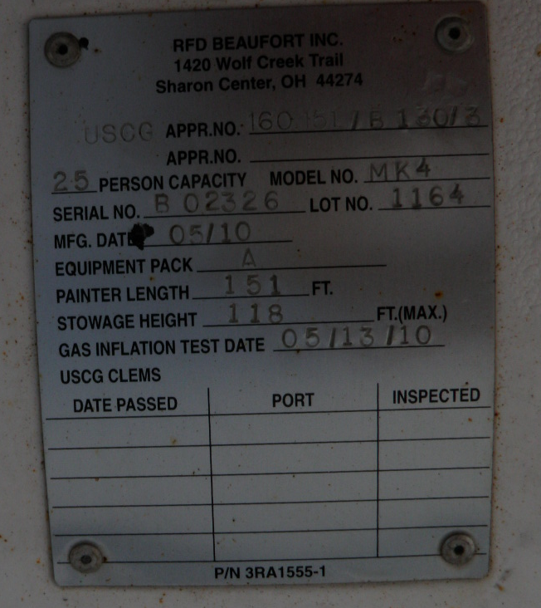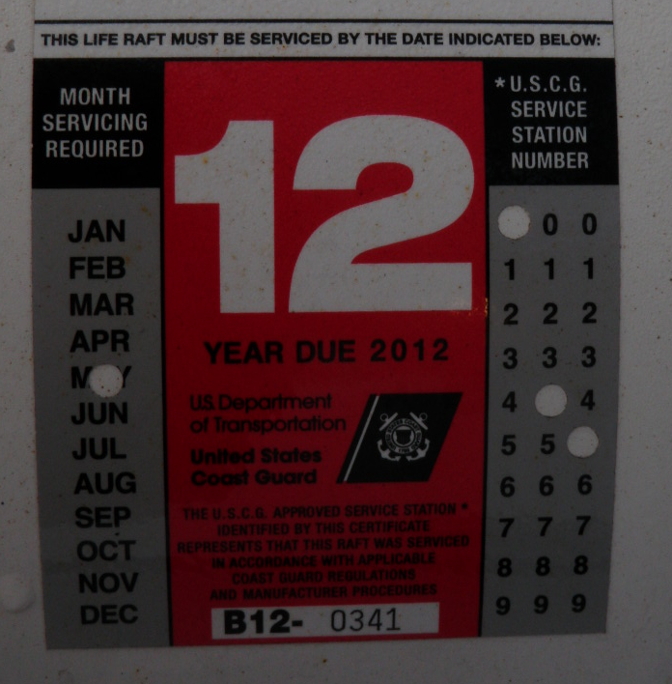

The life raft does not have a hydrostatic release and is tied down with line.

The EPIRB is mounted right outside the wheelhouse in a float free location. It’s a ACR Satellite2 406™ Cat I. There is a life ring mounted next to the EPIRB.

According to the station bill posted in the galley, there is a crew compliment of 25 (excluding the observer). The observer should go to the wheelhouse in all emergency situations.

At noon, you talk to the mate again and reiterate that there are a few items on the check list you were unable to account for on your own. He says he can meet you in the galley at 12:30.

You’ve prepared a list of items you were unable to gather yourself:
- EPIRB battery expiration – need to open cover to see: 31 December 2010.
- PFDs for crew – 30 stored in rain gear room.
- Radio operation, alarms, GPS – There are 2 VHF & 1 SSB radio in the wheelhouse. Luckily, there is also a very basic list of information about the vessel posted above it. The mate shows you how to use all the radios.
- There is 1 GPS and he shows you where the readout is.
- The mate also demonstrates the sound of the general alarm which they use for fire & flooding. He instructs you to come to the wheelhouse in the event that any sort of alarm goes off.
- There is no high water alarm.

He shows you the following a bench compartment in the wheelhouse that has the following flares stored in a metal, watertight box.

Parachute – exp 1 June 2012
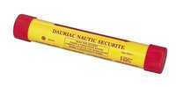

Smoke – exp 1 Aug 2013
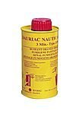

Handheld – exp 1 May 2011
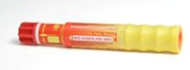

There is also a first aid kit in this storage compartment and the mate tells you that the cook has some medical training.

There were no drills held while you were on board.

