Demersal and Semi-Pelagic Longline

Learning objectives
- Describe 4 components of demersal longline gear
- List the 2 forms that must be completed that are specific to demersal longline vessels
- List 3 pieces of information that must be collected from each organism

Introduction
Longline gear is one form of hook and line gear that uses baited hooks to attract and catch fish. Demersal longlines (also known as bottom, set or anchored longlines) are similar to pelagic longlines except the gear typically fishes on or near the bottom (Figure 8-1) and targets bottom-dwelling fish such as the gadoids (cod, hake) and some shark species. You may also encounter vertical longlines although these typically target reef fish or are fished near FADs ((Preston et al. 1998); see Chapter X for information on other fixed gears). Hook and line gear of all types accounts for approximately 10% of global fisheries catch (Watson et al. 2006).

In general, longlining is considered to be selective in the size of fish captured (e.g., larger hooks catch larger fish). Many fish species remain alive and can be returned to sea with a high survival rate; however, there is potentially a higher impact on bycaught fish with swim bladders due to the effects of barotrauma and the habitat effects on the ocean floor. There are also concerns regarding the bycatch of sharks and seabirds in a few demersal longline fisheries (FAO 1999).

List of Priorities
- Estimate effort and total catch for each gear deployment;
- Identify every individual caught on each randomly selected set (or subsample within the set) and estimate percent retained;
- Collect biological information on target and other identified species as requested;
- Record all sightings and interactions with marine mammals and sea turtles;
- Record vessel and fishing gear characteristics.

Gear Description
Demersal longline gear can have a multitude of configurations (Figure 8-1). The most common is the single-line system which consists of a single groundline with hooks attached by smaller lines called gangions. The double-line system (sometimes called the “Spanish” longline system) has a floating line which runs parallel to a groundline and is connected to the groundline using several dropper lines. Both the single and double-line systems are configured with evenly spaced baited hooks attached by gangions and can be fished completely on- or off-bottom. The latter is also known as a semi-pelagic longline and the groundline is brought off-bottom by attaching regularly spaced floats. These gear subtleties will be differentiated on the Gear Description and Set and Haul Information forms but sampling is functionally the same so they’ve been combined for the purpose of this manual. Demersal longline length ranges from a few hundred meters (small-vessel fisheries) to as long as 50 km in the larger vessel, industrial fisheries (FAO 2001-2010).

The main components of a demersal longline are the groundline (also known as the mainline or fishing line), gangions (gangline, branchlines or snoods), hooks, floats, anchors and gear markers (Figure 8-1). The double-line configuration also includes the mainline (topline or motherline; Figure 8-1C). The groundline is the backbone of the gear and is typically a synthetic multifilament line. Gear may be stored in discrete sections called baskets (tubs or skates/magazines) which have 20 to 1,200 hooks or the groundline may be wound directly onto a single drum (snap system). Gangions are typically shorter than in pelagic gear ranging from 1-5 m and may be permanently attached to the groundline (direct splice or swivel) or attached to each set using snap (or clip; Figure 8-2). Gangions are relatively simple consisting of one type of line material between the groundline and the hook. Hooks are attached to the lower end of the gangion and there are a variety of shapes and sizes although the most common are the tuna, circle and J-hook styles (Figure 8-3). The baiting of hooks may be manual or by a machine (automatic baiting machine). Line shooting machines that pull the gear off the vessel at a consistent speed may also be used. Vessels are typically equipped with a hydraulic line hauler for gear retrieval.

Gear markers are used to mark the location of the fishing gear and may include buoys (floats), radar reflectors (highflyers), radio beacons, GPS beacons and lights (Figure 8-4). Floats may also be attached to the groundline in order to float it above the bottom (Figure 8-1B).

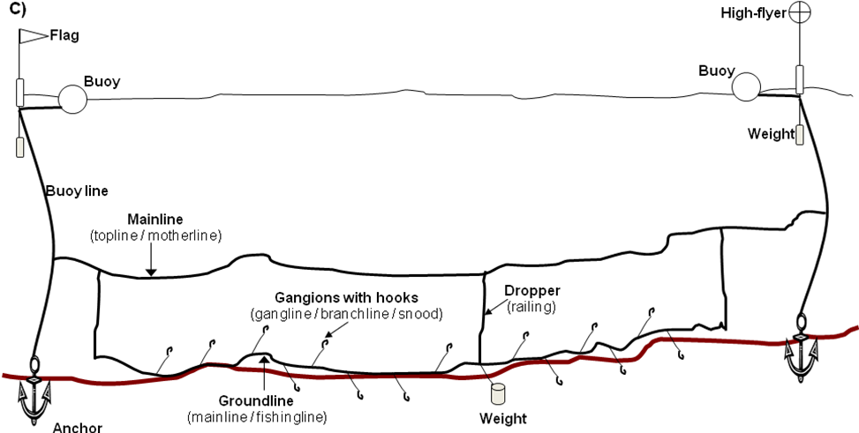

Figure 8-1 Demersal longline gear configurations and components: A) single-line, on bottom; B) single-line, off bottom; C) double-line, on bottom. Figures created using terminology from Hanrahan et al. (1997), Bjordal and Lokkeborg (1996), Brothers et al. (1999), and CCAMLR (2006).
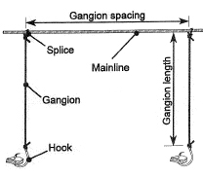
Figure 8-2 Gangion configuration. Gangions can be spliced directly to the mainline or be connected with a swivel or snap. The braided (multifilament) line and monofilament are two examples of gangion materials. Figure from Hanrahan et al. (1997).

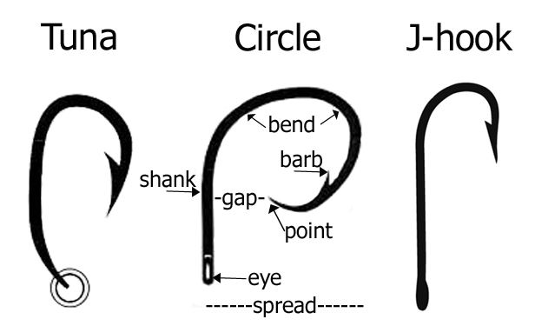
Figure 8-3 Basic hook types and terminology. The J-hook shank is parallel to the point and is shaped like the letter “J”. Circle hooks have a point that bends in at approximately 90° and the tuna hook has a bent shank. Modifed from Beverly (2006, 2009).

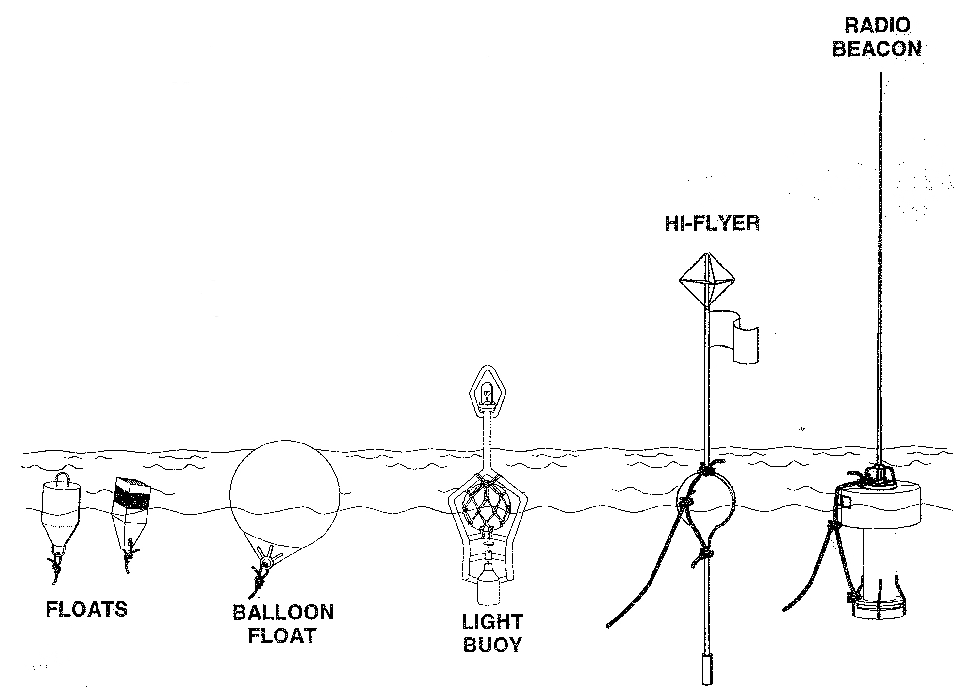
Figure 8-4 Types of gear markers. Modified from Hanrahan et al. (1997).

Fishing Description
Gear deployment: The longline is typically deployed from the stern of the vessel (Figure 8-5) and may also be referred to as setting or shooting. An end buoy with a gear marker is deployed first followed by buoy line and an anchor. The horizontal section may start with some running line (without hooks) and then the groundline. As the vessel steams away from the end buoy, gear is pulled from the vessel. Crew may attach gangions, weights and floats at desired intervals as the groundline is payed out similar to pelagic longline deployment or pre-baited hooks already attached to the groundline may be pulled from the vessel through a setting chute. A set terminates when the last anchor and end marker buoy is deployed. The vessel travels at 2-10 knots while gear is being deployed. The length of the groundline, ideal fishing depth and number of hooks per gear unit varies with the intended target. Fishing depth is a function of the number of floats and their spacing and dropline length (double-line configuration).

Gear retrieval: Longlines are left in the water from several hours to a day. Gear retrieval begins by locating the gear marker at one end of the groundline, then hauling it and the buoyline onboard. The groundline could be hauled by hand but more typically it is fed into a line hauler (block) and the gear is pulled in mechanically. Commercial fish are brought on board using gaffs whereas bycatch is typically discarded as the gear comes on board. The groundline can be stored in a coil that gets tied together, coiled into in containers (tubs, baskets) or stored on racks (autoline systems). If gangions/hooks were deployed manually, these snaps are removed individually as the gear comes back aboard. The rate at which hooks come on board depends on weather, fishing depth, hook spacing and crew experience; however, in general, a hook should come up every few seconds.

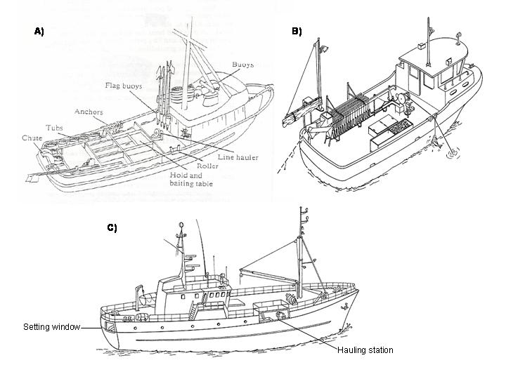
Figure 8-5 Generalized layout of small (A, B) and large (C) demersal longline vessels. Images from (NWFSC 2006) and (FAO 1985).

Forms/Instructions

Gear Description Form – Demersal Longline
Complete once per trip (see Figure 8-7 for an example). Most gear information can be obtained from the captain or deck boss.

Field | Definition
Observer Code: | Record your observer identification code.
Vessel Code: | Record the vessel code (Error: Reference source not found). If your vessel is not on this list, contact the SOP immediately.
Trip ID | Enter the trip identification number assigned by the SOP.
Lines | For each type of line found on board, record the material code, diameter (millimeters), breaking strength (or test; kg), number of strands and color code. It is normal for there to be only one groundline and one gangion type. If the vessel uses different gangion materials, gangion lengths or gangions constructed with two or three types of material, record the additional line types under type 2 and add additional gangion types as necessary.  If the vessel is using the double-line system, use the additional rows provided to record the materials for the mainline (topline).
Material codes include:
1 – Monofilament
2 – Mulitifilament / synthetic fiber
3 – Cotton or other natural fiber
4 – Steel wire
5 – Other (please specify, e.g. tarred red polyester, Kuralon™)

Color codes
1 – White | 5 – Blue | 9 – Yellow
2 – Pink | 6 – Red | 10 – Other
3 – Black | 7 – Clear | 11 – Multi-color
4 – Green | 8 - Orange

Record any additional information about each line in the comments box.

Hooks | For each type of hook used by the vessel, record the manufacturer, model/pattern, size, material, and degrees of offset. The common model/patterns include the tuna hook, J-hook and circle hook (Figure 8-3). If the shank is flat (rather than round), make a note of this in the comment section.  Hook sizes are not standardized among manufacturers. They may be in a metric unit or another convention that uses a slash (e.g., 9/0). Record what is on the box. If no information is available from the manufacturer, either bring a sample back or take a photo including a side and front view with a ruler for scale.  Hooks may be stainless steel (shiny) or galvanized (dull) but verify the material with the captain (Beverly 2009).  Offset is measured in degrees. A hook is offset if the point does not line up exactly with the shank when the point-side is facing you (Figure 8-6). Offset hooks do not lay flat.  Figure 8-6 Offset (left) and non-offset hooks. Image from Beverly (2009).
Floats | Excluding end buoys at the surface, describe the types of floats attached to the groundline. Floats may be used to keep the gear slightly off bottom (Figure 8-1B). Include the shape descriptor, approximate dimensions and material (e.g. foam, hard plastic, etc.).
Weights | Excluding anchors attached to the ends, describe the types of weights attached to the groundline including material and average weight. For example, a vessel may use 5-kg lead cannonballs (spheres) or 8-kg concrete cylinders.
Gear Deployment Location | Check appropriate box for whether longline gear was deployed from the stern, starboard or port of the vessel. If from the side, also record the distance from the stern (in meters).  Check appropriate box for whether the gear was deployed into the propeller up- or down-wash.
Other equipment | For each device, circle Yes or No for whether the device was present on board and record a usage code defined as:
  1 | Used continuously during fishing | 5 | Rarely used
  2 | Used often during fishing | 6 | Used only during transit
  3 | Used sometimes during fishing | 7 | No longer used
  4 | Broken during this trip but used normally | 8 | Unknown
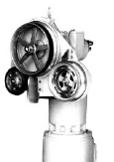  Mainline hauler – uses hydraulic motor to assist with pulling gear on board. |  | 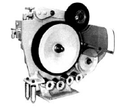  Line setter / shooter – used to pull mainline from drum or deploy mainline at a consistent speed during setting
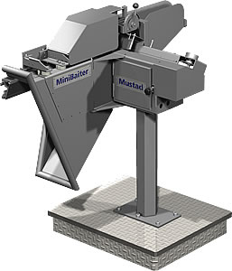  Automatic baiting machine – bait is fed into a slot where it is automatically cut and as gear is deployed, bait is applied to the hook automatically. Image: http://www.mustad-autoline.com |  | 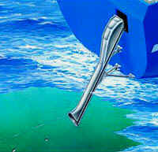  Setting tube – gear deployed slightly subsurface through a tube.  Image: http://www.mustad-autoline.com

Seabird Mitigation: Describe all techniques and equipment used to deter birds from hooks during the set and haul (e.g. bird curtain). Include diagrams with measurements of streamer lines and other equipment as necessary.

Figure 8-7 Example Gear Description for Demersal Longline.

Set and Haul Information Form – Demersal Longline
The Set and Haul form is used to record the basic fishing effort parameters of all longline sets during observed trips ( contains an example). The information necessary to complete this form is obtained through direct observations and crew input. If an element is not available or applicable, leave the field(s) blank and describe the situation in the Comment section. Fields indicated with an asterisk (*) relate to fields on Gear Description form.

Field | Definition
Observer Code: | Record your observer identification code.
Vessel Code: | Record the vessel code (Error: Reference source not found).
Trip ID | Enter the trip identification number assigned by the program.
Set No. | Record the set number (unique and consecutive for each trip).
Target | Ask the captain for the intended target species for each set. Record using 3-digit FAO code (Appendix 7). This will likely remain constant for a trip.
Page ___ of ___ | Number pages consecutively throughout the trip.
Several fields must be collected at the beginning and ending of each set and haul period. It may take more than two hours to set (deploy gear) and over six hours to haul (retrieve) a set. For each gear deployment, you will record four dates and times and two positions.

Date | There are separate columns for day, month and year. Record 2-digits in each column.
Time (24-hr) | Record time for each component using 24-hr notation (e.g., 8:45 a.m. = 0845 and 2:12 p.m. = 1412). Start and end setting times are defined when the first and last hooks go in the water, respectively. Start and end hauling times are when the first and last hooks come back on board, respectively.
Lat-Deg | Record degrees of latitude (2-digits) for start and end of the set. Start is where the first hook enters the water and end is where the last hook is deployed.
Lat-Min | Record the minutes of latitude (to hundredths of a minute; 4-digits)
Lat-N/S | Record N for all latitudes North of the equator and S for latitudes south of the equator.
Long-Deg | Record degrees of longitude (3-digits).
Long-Min | Record the minutes of longitude (to hundredths of a minute; 4-digits)
Long-E/W | Record W for all longitude West of the prime meridian (e.g., 0º) and E for longitudes east of the prime meridian.
V / O | Record O if the observer independently recorded times and positions for gear deployment. Record V if the information was obtained from a vessel’s fishing log or the captain.
Set Speed | Obtain the average setting speed (tenths of knots) from captain or GPS during setting.
Bottom depth (m) | Record average bottom depth in meters. Ask the captain or record from depth sounder. If you need to convert units (e.g., feet to meters), record conversion calculation in comments section.
Fishing depth (m) | If the gear is not set on bottom, ask the captain to estimate how far off bottom he is targeting or what he thinks his fishing depth is. If you need to convert units, record conversion calculation in comments section.
Seabird mitigation (set) | Enter code for any mitigation used during gear deployment. Options include:  0 - None  1 - Bird scaring line - single  2 - Bird scaring line - double  3 - Weighted branchline/gangion  4 - Weighted groundline  5 - Underwater setting tube/chute  6 - Moon pool  10 - Other - explain in comments. Use this code if more than one of the techniques was used and explain in comments.
Estimation Method | Record the code for total catch estimation method used for this set. Section 8.7 describes these more fully. Options include:  1 – Weigh entire catch  5 – Captain / vessel estimate  6 – Catch / effort ratio (not sampled)  7 – Catch / effort ratio (tally sample)  9 – Other – explain in comments
Total Catch | Record total catch to nearest hundredth of a metric ton. Record detailed calculations in the Observer Logbook.
Haul Dir. | Circle F or R for the haul direction. Forward is defined as the same direction gear was deployed and reverse is the opposite direction as gear was deployed.
Seabird mitigation (haul) | Check box if seabird mitigation was used during gear hauling.
Hooks – Type* | Record the dominant hook type deployed for the set. Hook type should relate to the type number on the Gear Description- Demersal Longline form. If more than one hook type is deployed in a set, record the dominant hook type and make a note in the comments section about the approximate percentage of each hook type. For instance, “80% hook type 1 and 20% hook type 2 were deployed.”
Hooks/section | Record the mean number of hooks attached per gear section. See “Determining Amount of Gear in a Set” for more information (Section 8.8.1.2).
Total sections | Record the total number of sections deployed. Ask the captain or crew. You will need to periodically verify this count yourself.
Set | Record the total number of hooks set. Calculate using the formula:  (Hooks/section * total sections)
Hauled | Record the total number of hooks retrieved. Tally missing hooks as gear is hauled and subtract the number missing from total hooks set.
Tended | Record the number of hooks tended while gear is soaking prior to hauling the gear. This practice may be called ‘hotlining’ and is more common on vessels fishing with pelagic longline gear and using live bait.
Rebaited | Record the number of hooks rebaited prior to hauling the gear.
Monitored | Record the number of hooks monitored. See catch composition tally sampling below (Section 8.8.1.4). This number should match the sample size on the Catch Composition form.
Gangion – Type* and Length | Record the dominant gangion type deployed for the set. Record gangion length (Figure 8-2).
Distance between | Record the distance between gangions (in meters). You may need to measure the hook spacing for 20-30 hooks to calculate an average. It is likely that this will remain consistent throughout a trip.
Weight (g) and weight placement | Record the full weight of any weight attached to each gangion. This may be incorporated into the swivel(s) or added separately. Make a note where the weights are located (e.g., 30g swivel attached 5cm above hook).
Floats | Record the type of floats attached to the groundline and note the approximate distance between them in meters.
Weights | Record the type of weights attached to the groundline and note the approximate distance between them in meters.
Bait – species and kg | Record the approximate weight of each species of bait used for the set. Ask the crew or pay attention to number of boxes/bags of bait used by species. Record to lowest taxonomic level possible.
Gear condition? | Indicate the condition of the gear at the completion of the haul by recording the most appropriate code defined as follows:
  0 | No problems (<10% hooks lost and/or minor gear damage)
  1 | Minor problems – 10-25% hooks lost and less than 50% of gear fouled due to weather/oceanic conditions. Gear tangled, spun up affecting gear fishability
  2 | Major problems – >25% of hooks lost and > 50% of gear fouled due to weather/oceanic conditions
  3 | Gear completely damaged or lost
  4 | Gear conflicts (with another fisher). Record details in comments including the other vessels name and relevant identifying features. If IUU fishing is suspected, be sure to fill in the Vessel and Aircraft Sighting form (Chapter 13).
  5 | Other – explain in comments
Gear parted? | Did the groundline part (or break) during gear retrieval? Circle Yes or No. If yes, make notes in comments regarding parting time and when gear hauling resumed.
Gear lost? | Was any gear lost during this set? Circle Yes or No. If yes, make notes in the comment section.
Light Devices - Type | Circle the predominant type of light device attached to gear. If more than one type, make a note in the comments.
Light Devices – How many? | Record the total number of light devices attached to the gear. If type=none, leave the remaining Light Device fields blank.
Light Devices – Placement | Record where the majority of the light devices were attached to the gear.
Color code & percent | Record the color code and approximate percentage of each color deployed. For example, Code 2 – 50% and Code 8 – 50%. Note that percent recorded must sum to 100%.  Color codes:
  1 – White | 5 – Blue | 9 – Yellow
  2 – Pink | 6 – Red | 10 – Other
  3 – Black | 7 – Clear
  4 – Green | 8 - Orange
Other devices | Check appropriate boxes if temperature-depth recorders (TDRs), hook timers, or any other devices that may impact fishing effectiveness were deployed. If Other is checked, describe more fully in the comments section.
Comments | Use this section to describe any particulars that could not be codified from the available data element choices. If you run out of space, indicate that there are notes elsewhere (e.g., page X in Observer Logbook).

Figure 8-8 Example of completed Set and Haul Information form.

Total Catch Estimation
Total catch must be estimated for every set. There are four options on demersal longline vessels:

- Weigh entire catch (method 1) – If catch is extremely small, you may be able to weight the entire catch. This is unusual.

- Captain / vessel estimate (method 5) – Use the captain’s estimate only if you are unable to use methods 1, 6 or 7.

- Catch / effort ratio (method 6) – Use this method when you are unable to sample a set. Use the tally sample from similar sets (i.e., similar area, depth strata, time) to estimated the total catch in an unsampled set.
(Σ Sample weights from similar sets / Σ Tallied hooks from similar sets ) * Total hooks in unsampled set

- Catch / effort ratio (method 7) – Divide the sample weight by number of hooks sampled and multiply by total hooks in the set

(Sample weight / Tallied hooks ) * Total hooks in set = Total catch

If a method other than the above is used, record as method 9 and explain in comments.

Catch Composition and Biological Data
Demersal longline vessels may make multiple sets per day. Section 5.2 and the Observer Logbook fully describe how to use the Random Sample Table to select sets to sample for species composition.

Section 3.6 described random sampling but the next section will provide more detailed examples regarding how to subsample hooks within each set. During the selected tally sample, all fish will be counted (tallied) to the lowest taxonomic level. You will also collect fish to obtain weights and estimate the percent retained. Demersal longline catch composition data is recorded on the generic catch composition form described in Section 5.4 and an example specific to demersal longlining is at the end of this section (Figure 8-9).

Figure 8-9 Example of completed Catch Composition form for demersal longline.

Tally sampling
The standard catch composition sample type for demersal longline gear is the tally sample (ST=4) since the catch comes on board individually and the number of fish may be easily counted. When tally sampling, observers count all individuals by species (or species group) as they are brought out of the water. The count (tally) is then multiplied by the average weight of fish (determined through weight sampling) to obtain the estimated weight of each species in your sample (Flewwelling et al. 2002). For bycatch species, where you weighed the actual number tallied in the sample, the weight recorded is the actual weight. However, before you begin sampling you need to define a set, determine the amount of gear in a set, determine how much and which sections of the set you will sample (tally) and determine where you will tally and weigh fish.

Defining a Set
Defining a set of conventional demersal longline is straightforward. A set begins at a buoy and ends at a buoy. The set includes all of the hooks in between the two buoys. All the hooks set together in a string, even those lost prior to retrieval, are included in the set.

Determining Amount of Gear in a Set
In order to devise an appropriate sampling frame, you must determine the amount of gear in the set. This is fairly easy to determine when gear is stored in discrete units but there are some gear configurations without discrete units (e.g., snap gear). Vessels fishing with discrete units of gear can vary how many hooks are fished in each set by increasing or decreasing the number of units deployed. Interview your captain to determine whether or not the gear is divisible into consistent (or fairly consistent) units. Determining the number of hooks in a set is different for these two situations.

Pot, snap longline or other gear that is not divided into discrete units.
To determine the number of hooks set, you will need to count all of the hooks or pots in the set. The options for counting hooks, in order of preference, are:
- Count hooks/pots while the gear is stored on the vessel.
- Count hooks/pots while they are being baited.
- Count hooks/pots during gear deployment (the setting of gear).
- Count hooks/pots while gear is being retrieved on sampled hauls and ask skipper if any gear was lost. This can be extremely difficult, especially when you need to sample for species composition at the same time. Also, counting hooks in the evening, morning, and night can be difficult due to available light.
- Counting hooks/pots while gear is being retrieved on unsampled hauls. If you do not believe you can obtain an accurate hook/pot count while sampling, then you can take one haul off per day to count hooks/pots. This only works if all sets have the same number of hooks/pots.

Gear that is divided into discrete units
Determining the number of hooks set can be easier with this type of gear. There are two things you must determine:
- Average number of hooks per unit
- Number of units deployed in a set

Average number of hooks per gear unit:
Vessels generally have a consistent number of hooks per unit of gear. Always document in the Observer Logbook when average hook counts were done and why that time was chosen.
- Count the number of hooks on a gear unit for at least 1/5 of the gear being used each trip. It is usually possible to count hooks while gear is being baited, stored or deployed.
- Sum the hook counts for all the gear units counted and divide by the number of gear units counted to determine average number of hooks per skate.

Average # Hooks per gear unit = ∑Hook Counts ∕ # of units counted

Number of units in a set:
Count the number of units in a set:
- During deployment of gear;
- During retrieval of gear. If gear unit counts are done during retrieval of gear, ask skipper if any gear was lost. It can be difficult to count the number of gear units during retrieval, as section markers are sometimes hard to distinguish;
- After gear retrieval.

If you cannot get an accurate count of the total number of gear units set, ask the captain for an estimate. If you need to rely on the captain’s estimate, a verification of gear units per set must be done once each day. This can be accomplished by counting skates during one of the following times:
- While gear is being set.
- After a set is completed and all gear is on board vessel.
- While gear is being retrieved.

Determining the Total Number of Hooks in a Set
Total Hook Count = Total # of sections * Average # Hooks per section

Determining which sets to sample
If you are unable to tally sample every set, use RST#1 to select which sets to sample. See further instructions in Section 6.7.2 and the Observer Logbook.

Determining the Amount of Gear to Sample
At minimum, 1/3 of a set must be tallied, 1/2 would be ideal. There should only be one sample size for the tally sample (e.g., tally all species, retained and discarded, during the tally sample).

Randomly Selecting Gear to Tally Sample
If less than 100% of a set is going to be tallied, a random sampling frame must be designed (see also section 3.6). There are four choices for designing a random sample frame:
- Systematic spatial with a random start (preferred)
- Random (Non-systematic) spatial
- Systematic Temporal
- Random (Non-systematic) Temporal
Fixed-gear vessels routinely set over of a depth gradient or across different bottom types. This means the catch can vary significantly along a set. The best way to account for the variability caused by setting across a depth gradient or different bottom types is to use a systematic sampling frame.

Spatial Sampling
Spatial sampling is gear-based and involves randomly selecting sample units from the set to tally. Spatial sampling is ideal when gear consists of discrete sections.

Systematic Spatial Sampling with Random Start (preferred method)
Instructions - Example in italics

- Define population to be sampled -A longline set of 100 gear units.
- Define your sample frame – Systematic spatial with random start based on gear unit.
- Define your sample units (# of gear segments in a sample unit may vary from haul to haul) – Blocks of 5 gear units.
- Number all the sample units in your sampling frame – Sample units numbered as 1-20 (100 gear units in 5 unit increments: (1-5), (6-10), (11-15)...(96-100))
- Determine how many of the sample units you want in your sample (minimum of 1/3 of set). Decide you want to sample ½ of the string, so need to tally 10 sample units.
- Divide the total number of sample units by the number of units you want in your sample. This gives you your value for “n”. n = 20/10 = 2
- Randomly select a number between 1 and n. This will be the first sample unit in your sample. Use random number table to select a number between 1 and 2. Randomly select 2.
- Sample every nth unit thereafter. In this example the ‘sample units’ tallied would be 2, (2+2)…. (18+2), so the gear sampled would be units (6-10), (16-20), ……(96-100).

Random Spatial Sampling (Non-systematic)
Instructions - Example in italics
- Define population to be sampled -A longline set of 30 gear units.
- Define your sample frame – Spatial, based on gear unit.
- Define your sample units (# of gear segments in a sample unit may vary from haul to haul) – Blocks of 3 gear units
- Number all the sample units in your sampling frame – Sample units numbered as 1-10 (30 gear units /3 unit increments=10; (1-3), (3-6), (7-9),……(28-30))
- Determine how many of the sample units you want in your sample (minimum of 1/3 of set). Decide want to sample 4 of the 10 sample units.
- Pick random numbers to choose which units to sample. In this example generate 4 random numbers between 1 and 10 (the maximum sample unit number) to determine which sample units to tally. Number 3, 7, 9 and 10 are randomly selected.
- Tally sample the randomly selected sample units – Tally sample gear units 7-9, 19-21, and 25-30. (Since 2 consecutive sample units, 9 and 10, were randomly selected, the last tally period includes 6 gear units).

**Always start the sample at the beginning of a gear segment. (For longline gear, begin at a gear unit knot!) Never start sampling in the middle of a gear segment. If you miss the start of the gear segment, start at the beginning of the next gear segment and make notes that this occurred.

Temporal Sampling
Temporal sampling is time based. In order to use this type of sample system you must know the approximate length of time it will take to haul a set. Temporal sampling may be more appropriate when gear units are not into discrete sections. Examples of both systematic and non-systematic temporal sampling follow:

Systematic Temporal Sampling with Random Start
Instructions - Example in italics
- Verify the length of time needed to haul the set by asking the skipper or a crew member – Captain tells you it will take 6 hours to haul a string.
- Define population to be sampled – All hooks on the string.
- Define your sampling frame – Systematic temporal, based on units of time.
- Define your sample units – 1/2-hour blocks of time (length of time that defines a sample unit may vary from string to string).
- Number all the sample units in your sampling frame – Sample units numbered as 1 – 12 (6 hours in ½ hour blocks; 1-30 min., 31-60 min. ….…331-360 min.)
- Determine how many of the sample units you want in your sample (minimum of 1/3 of set). Decide to sample 1/2 of the string = 6 sample units.
- Divide the total number of sample units by the number of units you want in your sample. This gives you your value for “n”. n = 12/6 = 2
- Randomly select a number between 1 and n. This will be the first sample unit in your sample. Use random number table to select a number between 1 and 2. Randomly select 1.
- Tally sample the first gear segment that begins in the randomly selected time period and continue tally sampling until the time period has ended and you have reached the end of a skate. Begin tally sampling when crew starts hauling the set and sample until 30 minutes have passed and you come to the end of a skate.
- Note how many gear units were tally sampled in each tally period so that you can calculate the total number hooks sampled for the set. (This number will vary depending on length of gear units and the speed at which gear is hauled.)
- Sample every nth unit thereafter. In this example the ‘sample units’ tallied would be 1, (1+2)…. (9+2), so the time segments sampled would be minutes (130), (61-90),…(301-330).

Random Temporal Sampling (Non-systematic)
- Verify the length of time needed to haul the set by asking the skipper or a crew member – Captain tells you it will take 4 hours to haul a string.
- Define population to be sampled -All hooks on the string.
- Define your sample frame – Non-Systematic Temporal, based on units of time.
- Define your sample units (length of time that defines a sample unit may vary from string to string) – 20-minute blocks of time
- Number all the sample units in your sampling frame – Sample units numbered as 1-12 (4 hours in 20minute blocks; (1-20 min.), (21-40 min.) ….…(221240 min))
- Determine how many of the sample units you want in your sample (minimum of 1/3 of set). Decide want to sample 5 of the 12 sample units.
- Pick random numbers to choose which units to sample. In this example generate 5 random numbers between 1 and 12 (the maximum sample unit number) to determine which sample units to tally. The numbers 3, 6, 8, 10 and 11 are randomly selected.
- Tally sample the first gear segment that begins in the randomly selected time period and continue tally sampling until the time period has ended and you have reached the end of a gear unit. Begin tally sampling at the start of the first unit that begins after the crew has been hauling the set for 40 minutes, and sample until an additional 20 minutes have passed and you come to the end of a gear unit.
- Note how many gear units were tally sampled in each tally period so that you can calculate the total number hooks sampled for the set. (This number will vary depending on length of gear units and the speed at which gear is hauled.)
- Sample all randomly selected time periods. In this example the time segments sampled would be minutes (41-60), (101-120), (141-160) and (181-220). (Since 2 consecutive sample units, 10 and 11, were selected, the last tally period is 40 minutes long.)

Observer should have their random sample frame designed prior to the start of haul back.

Where to Tally Sample
The tally station is where the observer stands to count organisms as the groundline is being retrieved. The tally station should be no more than six meters from where the fish are landed and the observer should have an unobstructed view of the fish as they come out of the water and are brought aboard. From the tally station, observers must be able to clearly identify fish and other species as they come aboard as well as be able to identify drop-offs.

Equipment Needed
A deck form, three to six thumb counters, a pencil and a clipboard will be needed for tally sampling. Prior observers have devised many innovative techniques to make using multiple thumb counters easier. The most common is to use duct tape to attach multiple thumb counters to a clipboard. Other observers have used duct tape and line to create thumb counter belts that fit around the waist. Observers should be creative, experiment, and find out what works best. You will also need scales and several hooks for weighing fish.

Sample weights

Set up a location to safely weight fish during the non-tally periods. Coordinate with the crew in advance how bycatch species will be stored while you are tallying. During the tally sample, ask the crew to set aside bycatch for you to be weighed. Weigh target catch during the non-tally periods. Randomly select and weigh 40-50 individuals of each target in order to get an average weight. Attempt to spread out the collection across multiple non-tally periods. For example, if there are five non-tally periods, collect approximately 10 fish in each period for average weight sampling.

